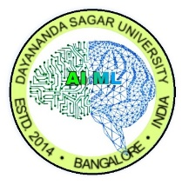

DAYANANDA SAGAR UNIVERSITY

Department of Computer Science & Engineering
(Artificial Intelligence & Machine Learning)
Devarakaggalahalli, Harohalli, Kanakapura Road,
South Bengaluru Dt., Karnataka - 562112, India
CERTIFICATE
This is to certify that the Internship report, entitled Rahul V, a bonafide student of Bachelor of Technology in Department of Computer Science and Engineering (Artificial Intelligence & Machine Learning) at the School of Engineering, Dayananda Sagar University, Bengaluru in partial fulfillment of the requirement for the VIII semester during the academic year 2025-2026. It is certified that all the corrections/suggestions indicated for Internal Assessment have been incorporated in the report. The Internship report has been approved as it satisfies the academic requirements in respect of Internship prescribed for the VIII Semester.

External Guide Name | Internal Guide Name | Chairperson
Drishti Madaan | Dr. Joshuva Arockia Dhanraj | Dr. Jayavrinda Vrindavanam
HR Manager | Professor | Professor & Chairperson
Unified Mentor Pvt. Ltd. | Dept. of CSE(AI&ML), | Dept. of CSE(AI&ML),
Gurugram, Haryana | School of Engineering | School of Engineering
 | Dayananda Sagar University | Dayananda Sagar University
Date: 11/04/2026 | Date: 11/04/2026 | Date: 11/04/2026

